SACRED HEART PARISH

Sacred Heart Parish Founded 1814, The First Catholic Parish in the STate of New Jersey

Sacred Heart Church, 343 South broad Street, Trenton, New Jersey 08608

Holy Cross Church, 233 Adeline Street, Trenton, New Jersey 08611

ALL ARE WELCOME

Whatever your present status in the Catholic Church, whatever your current family or marital situation,

Whatever your past or present religious affiliation, whatever your personal history, age, background, or

race, whatever your own self-image or esteem, you are invited, welcomed, accepted, loved and

respected at the Parish of the Sacred Heart.

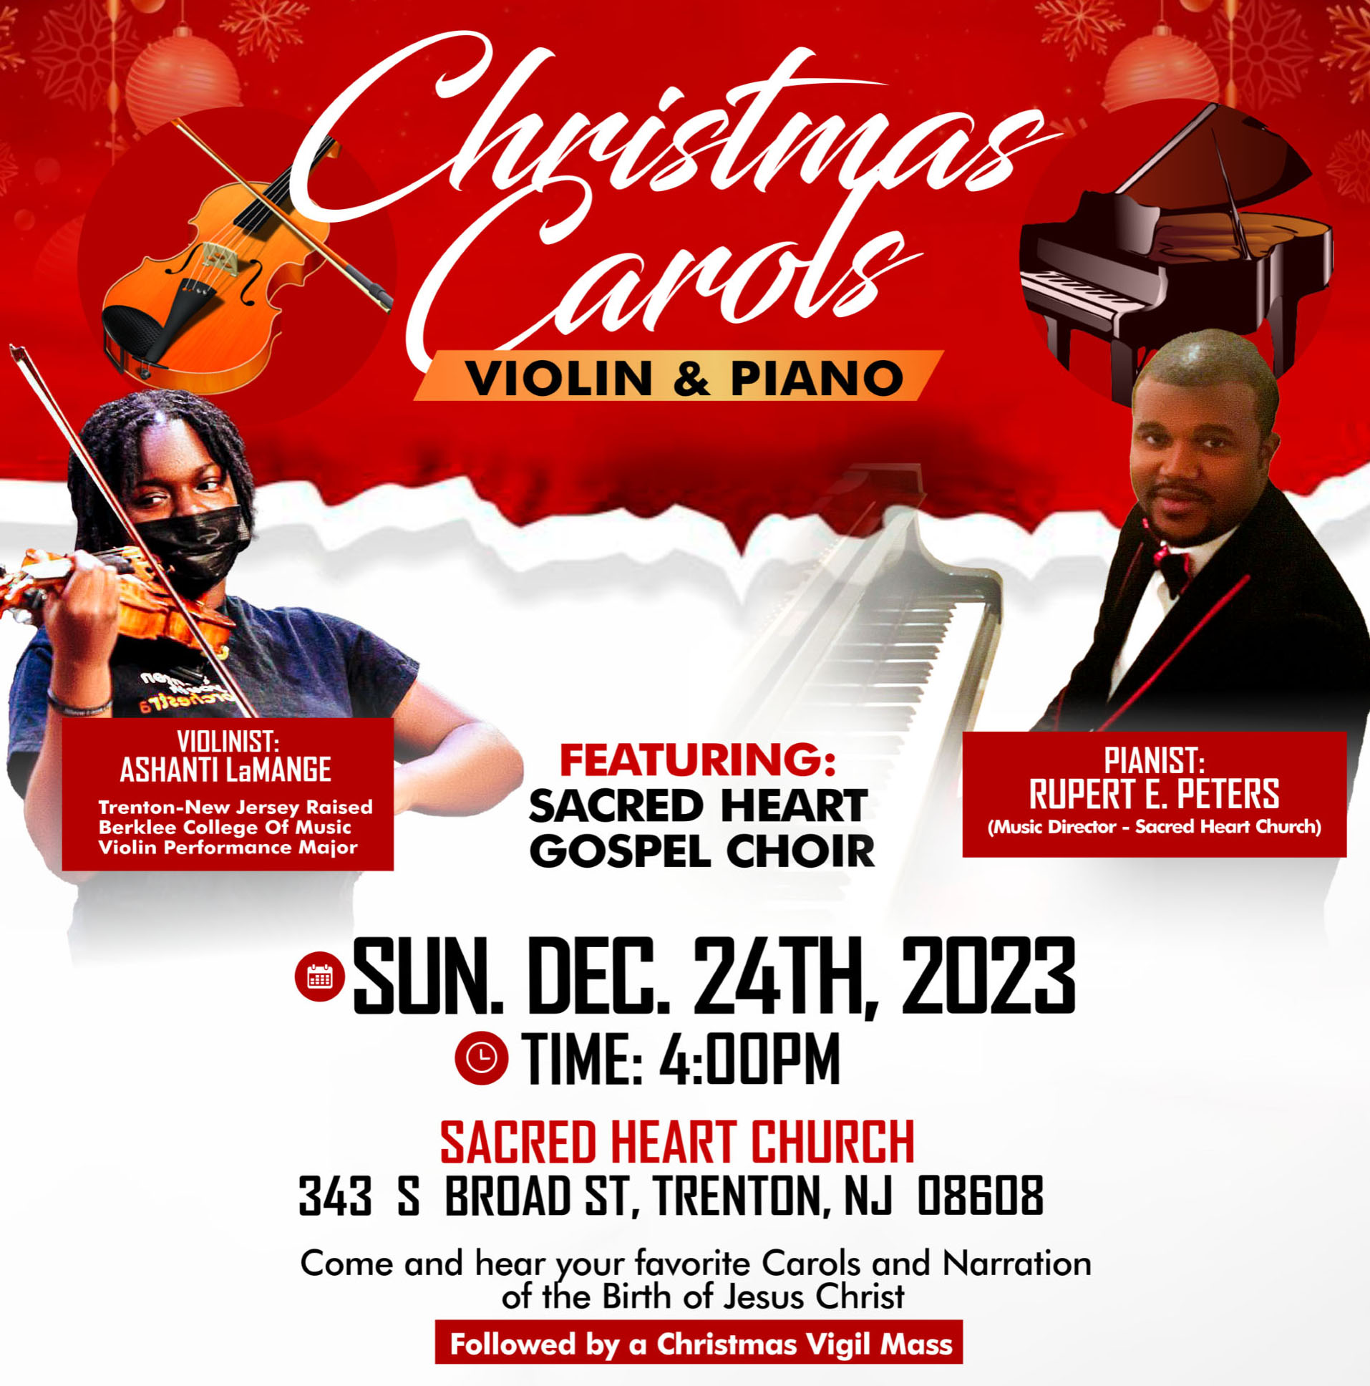

THIRD SUNDAY OF ADVENT ~ DECEMBER 17, 2023

MASS INTENTIONS
Saturday, December 16
4:00 pm~ Deceased members of the Littwin Family
5:15 pm SHC ~ Victor and Silvana Ladnyk
Sunday, December 17
9:00 SH ~ Ann Marie Lammerding
10:00 HCC ~ Intentions of the People of the Parish
11:15 SHC ~ Patrick Sheehan
12:00 HCC Polish~ Deata Mlodorzenice
Monday, December 18
8:00 am HCC ~ Christina LaRue
12:10 pm SHC ~ Ann Vispetti
Tuesday, December 19
12:10 pm SHC ~ Diana Cracker Amoroso
Wednesday, December 20
12:10 pm SHC ~ Rose Torrini
Thursday, December 21
8:00 am HCC ~ G.M. Salay
Friday, December 22
8:00 am HCC ~ Marie and Herold Feyl
12:10 pm SHC ~ Special Intention
Saturday, December 23
4:00 pm ~ Thomas & Pauline Lukowicz
5:15 pm SHC ~ Anna Vispetti
Sunday, December 24
10:00 SH ~ For the Deceased Priests of the Parish
10:00 HCC ~ For the People of the Parish
12:00 HCC Polish~ For Deceased Religious of the Parish
Sunday, December 24 ~ Christmas Eve Masses
4:00pm ~ Christmas Intentions
4:15pm SHC ~ Lessons and Carols
5:15pm SHC ~ Christmas Intentions
12:00 Midnight SHC ~ Christmas Intentions
Monday, December 25 ~ Christmas Masses
9:00 SH ~ Christmas Intentions
10:00 HCC ~ Christmas Intentions
11:15 SHC ~ Christmas Intentions
12:00 HCC Polish~ Christmas Intentions

OUR SICK LIST
Kristen Topley, Mary Sokolowski, Rocco, Lorraine Wargo, Robert Paci, Mrs. Loatman, David Carver, Jennifer Lyons, Grace Profy, Steve Jurczynski, Cornell Hess, Ruby Covington, Judith Santigo, Ching Kukis, Dan Breese Jr, Brenna Kennedy-Moore, Dawn Chia, Mark Friedman, Alexander A. Ladnyk, Kelly Nitti, Lauren Clayton, Joseph Edralin, Margie Tiongson, Kevin, Vincent Cooper, Jr., Gail Ladnyk, Leo Genovesi, Sloane Donnelly, Richard Buckley, Tony Ragolia, Barbara Burrows, Charles Burrows, Dorothy Amoroso, Maryann Sullivan, Regina Friedman, Stanley Winowicz, Greg Schafer, Jack Hardiman, Amy Birk, Julia Grazioli, Matt Tydryszewski.
OUR DECEASED
Robin Haynes, Betty O’Neill, Susan Cuniglio, Wilma Ruberto, and our friends at South Village, Riverside Nursing and Rehabilitation Center, Mill House and Waters Edge.

MINISTRY SCHEDULE
(subject to change)
Saturday, December 16
4:00pm HCC ~ Fr Charles L. M. Herpel Em. R. Micharski
5:15pm SH Msgr. Dennis L. R Hernandez Em. W. Lewis & T. Hines
Sunday, December 17
9:00 SHC ~ Msgr. Dennis L. J. McDonough Em. A. & C. Cruz
10:00 HCC ~ Fr. Charles L. A. Dodson Em. M. Williams
11:15 SHC ~ Msgr Dennis L. J. Laurenti Em. B. Dumont & J. Bautz
12:00 HCC Polish ~ Fr Charles Anna, Mieciu

Saturday, December 23
4:00pm HCC ~ Fr Charles L. C. Benitez Em. N. Saganowski
5:15pm SHC ~ Msgr. Dennis L. N. Kazior Em. J. Kazior & R. Hoyer
Sunday, December 24
10:00 SHC ~ Msgr. Dennis L. A. Urbaniak Em. J. Ellie & A. Green
10:00 HCC ~ Fr. Charles L. M. Days Em. F. Zielinski
12:00 HCC Polish ~ Fr. Marian Gosia, Ewa

WEEKLY COLLECTION
Last weekend’s collection amounted to $12,520.00. Thank you for your continued support of our parish.

2023 ANNUAL CATHOLIC APPEAL UPDATE
Goal: $33,000.00
Pledged: $46,592.00 (141% of Goal)

READINGS FOR THE WEEK
Third Week of Advent
Sunday Is 61:1-2a, 10-11; 1 Thes 5:16-24; Jn 1:6-8, 19-28
Monday Jer 23:5-8; Mt 1:18-25
Tuesday Jgs 13:2-7, 24-25a; Lk 1:5-25
Wednesday Is 7:10-14; Lk 1:26-38
Thursday Sg 2:8-14 or Zep 3:14-18a; Lk 1:39-45
Friday 1 Sm 1:24-28; Lk 1:46-56
Saturday Mal 3:1-4, 23-24; Lk 1:57-66

PROMISE TO PROTECT
The Diocese of Trenton is committed to the norms of the U.S. Bishop’s Charter for the Protection of Children and Young People in regard to the reporting and investigation of sexual abuse allegations involving minors. If you have been sexually abused as a minor by anyone representing the Catholic Church, you can report that abuse through the diocesan Hotline: 1-888-296-2965 or abuseline@dioceseoftrenton.org. Allegations are reported to the appropriate law enforcement agencies.

2024 CALENDARS
Our 2024 Calendars have arrived and are available in the vestibule of our Churches.

OUR GIVING TREE PROJECT ~ THANK YOU
All Giving Tree Gifts are back and have been distributed to the five agencies as promised. They are all so very grateful for your generosity and care of the needy people in our area. Thank you to all who brought the Christmas Spirit to so many homes.

BLOOMIN’ 4 GOOD PROGRAM
Sacred Heart’s Food Outreach Program has been selected by Stop & Shop to benefit from the Bloomin’ 4 Good Program. Our food pantry will receive $1 from every specially marked $10.99 Bloomin 4 Good bouquet sold during the month of December 2023 at the Stop & Shop located at 800 F Denow Road, Pennington NJ.

BLESSING OF THE INFANT JESUS
This Sunday, December 17th we ask that all of the Children of the parish attend the Family Mass at 11:15am Sacred Heart Church. We ask that they bring the baby Jesus from your nativity set so that the Infant may be blessed. If you do not have a nativity set please be creative with your children and make one with them or bring in a picture. Our Religious Education students will present “the Nativity” story for us.

FOOD OUTREACH PROGRAM
Monthly Food Collection is scheduled for this weekend, December 16th and 17^{th.} Food Bagging will be held on Monday, December 18th at 9:30am in Toomey Hall, with Food Distribution on Tuesday, December 19th at 1:30pm. Your help is greatly needed and appreciated.

CHRISTMAS FLOWER ENVELOPE
The Christmas Flower collection envelope can be place with the regular collection when it is appropriate for you to contribute. Thank you.

CHRISTMAS SCHEDULE 2023

SACRED HEART CHURCH
Saturday, December 23
5:15 PM Vigil Mass
Sunday, December 24
10:00 AM
The Nativity of the Lord ~ CHRISTMAS EVE
4:15 PM Christmas Presentation
Lessons and Carols
5:15 PM and 12:00 Midnight Mass
Monday, December 25 ~ CHRISTMAS DAY
9:00 AM and 11:15 AM
Tuesday, December 26 No Mass

HOLY CROSS CHURCH
Saturday, December 23
4:00 PM Vigil Mass
Sunday, December 24
10:00 AM and 12:00 Noon Polish
The Nativity of the Lord ~ CHRISTMAS EVE
4:00 PM
Monday, December 25 ~ CHRISTMAS DAY
10:00 AM Gospel and 12:00 Noon ~ Polish

NEW YEAR SCHEDULE
SACRED HEART CHURCH
Saturday, December 30 5:15 PM Vigil Mass
Sunday, December 31 10:00 AM
Feast of Mary, Mother of God ~
NEW YEAR’S EVE
Sunday, December 31 5:15 PM
Monday, January 1 ~ NEW YEAR’S DAY 10:00 AM

HOLY CROSS CHURCH
Saturday, December 30 4:00 PM Vigil Mass
Sunday, December 31
10:00 AM and 12:00 Noon
Feast of Mary, Mother of God
Sunday, Dec. 31 NEW YEAR’S EVE 4:00 PM
Monday, January 1 ~ NEW YEAR’S DAY
10:00 AM Gospel Mass
12:00 Noon Polish Mass

BLESSING OF HOMES
The Blessing of Homes will take place this year during the month of January. The Blessing includes a prayer that God will protect your family during the coming year. Your home will sprinkled with holy water and the initials of the Three Kings who visited and worshipped the Infant Jesus in Bethlehem are written above the lintel of the main door with blessed chalk (Caspar, Melchior, and Balthasar). The Blessing of Homes will begin the second week of January. If you are a registered parishioner and wish to have your home blessed, please complete the form below and return it in the collection basket or drop it off at the Parish Office.

Name __________________________________________
Address___________________________City________
Cell or phone number __________________

VOLUNTEER PARTY
The “Little Christmas” Volunteer Appreciation Party, will be held Friday evening, January 5th from 6:00 - 9:00 pm. We will begin with a prayer service at 6:00 pm in Sacred Heart Church followed by light refreshments in Msgr. Toomey Hall. All those who volunteer as Finance Council, Trustees, Ushers, Choir Members, Lectors, Ministers of the Eucharist, Altar Servers, RCIA Team, Catechists, Caregivers, Food Distribution & The Lord’s Table, Collection Counters, Parish Staff and all other volunteers are invited. Please R.S.V.P. by December 28th by calling the office at 609-393-2801 or by filling out the form below and place in the collection basket. Thank you.

VOLUNTEER PARTY
Name _______________________________
Number attending______________________
Cell or phone number __________________

GAUDETE SUNDAY
Today is Rejoice or Gaudete Sunday! We light the Rose candle and we are almost to Christmas! . On Gaudete Sunday, the season of Advent shifts its focus. For the first two weeks of Advent, the focus can be summed up in the phrase, “The Lord is coming.” But beginning with Gaudete Sunday, the summary might be, “The Lord is near.” This shift is marked by a lighter mood and a heightened sense of joyous anticipation. Liturgically, the colors lighten as well. The priest usually wears rose-colored vestments, a hue seen only on Gaudete Sunday and Laetare Sunday. In times when the focus of our anticipation is often on the negative and fearful, this celebration is a reminder that God who loves us is still in charge and that we await his coming not with fear, but with tremendous joy.
THIRD SUNDAY OF ADVENT
~ THE THIRD CANDLE ~
Rejoice! Here is your God! As the feast of Christmas draws closer, we are reminded that the Lord is with us even now. Jesus came to give sight to blind and life to the dead. Christ’s reign is among us through our deeds of love and generosity. Let us not grow weary, but steady our hearts and rejoice, for Lord is close at hand! (Light two purple and one pink candle)
Scripture: “Rejoice in the Lord always! I say it again. Rejoice! Everyone should see how unselfish you are. The Lord is near”
Prayer: Jesus, you are the light of the world. May your light shine brightly so we can see you everywhere. Help us to spread your light and joy by giving freely and happily to all we meet. Response: Come, Lord Jesus!
MEMORIAL CANDLES
If you’d like to remember a loved one on a special occasion such as wedding, birthday or in memory of someone (living or deceased) with a memorial candle, please contact the office. The yearly candles, located in the St. Joseph candle room, are one hundred dollars for one year and may be renewed yearly in January. You may order one at any time for an additional amount of $10 per month leading up to the January renewal date.

